مبینا دین پرست

تمرین شماره یک(کراپ کردن تصویر)

import cv2

import numpy as np

import matplotlib.pyplot as plt

image = cv2.imread('images/Lusin-1.JPG')

plt.imshow(image[...,::-1])

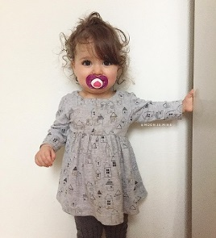

height, width = image.shape[:2]

# Simply use indexing to crop out the rectangle we desire

cropped = image[55:150 , 100:250]

plt.imshow(cropped[...,::-1])

<matplotlib.image.AxesImage at 0x1ff8ff9eb60>

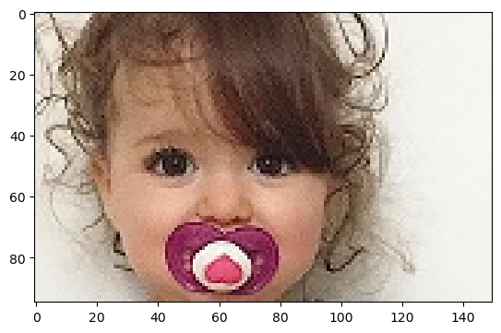

cv2.imshow("original", image)

cv2.imshow("cropped", cropped)

cv2.waitKey()

cv2.destroyAllWindows()